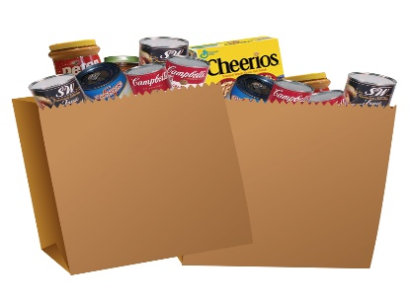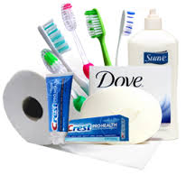

Here is some information that might be helpful:
Most Requested Food Items: Non-Perishable Foods
(highlighted items are needed the most)

• Canned Meat/Fish
• Peanut Butter
• Dry beans
• Canned Beans
• Rice
• Canned Vegetables
• Evaporated/Condensed Milk
• Condiments (salad dressing, ketchup, mayo, mustard)
• Canned Fruits
• Dried Fruits & Nuts
• Hearty Canned Soups/ Chili
• Oatmeal
□ Pasta Sauces
• Cooking Oil (24 oz. or smaller)
• Cereal
• Sugar
• Spices (salt, pepper, chili powder,)
Most requested non-food items: Personal Care

• Can openers
□ Deodorant
□ Sunscreen
• Dish Soap/Hand Soap
• All Purpose Cleaner
• Shampoo/Conditioners
• Body Lotion/Body Wash
□ Tooth paste/ Tooth brushes
• Reusable Grocery Bags
• Adult Diapers
• Feminine Pad/Tampons
• Toilet Paper/Paper Towels

